MS Project setup for Earned Value calculations
What must first be understood is what data MS Project uses to calculate the Earned Value numbers. MS Project uses costs to determine Earned Value. This cost is derived from two places; the standard labor rate entered for each resource, and the work effort attributed to a resource assignment for a task. If a resource does not have a standard labor rate and if a task does not have a resource assignment a cost cannot be calculated for the activity and therefore no Earned Value calculations will be made for the activity. To ensure that MS Project has the data it needs to calculate Earned Value, the following checks should be made against a schedule.

- Have resources been identified and labor rates assigned to each resource? This must be done before an assignment is made to a task.
Open the Resource Sheet and validate that ALL resources have a value greater than $0 in the ‘Std. Rate’ column.
  - Click the View tab. In the Resource Views section, click the Resource Sheet option.
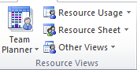

  - The Resource Sheet will display similar to the illustration below. If there is not a Std. Rate for a resource no cost can be calculated for work the resource is assigned to. Therefore, no ‘Earned Value’ will be calculated when time is recorded against the work.

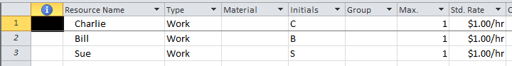

- Do ALL detail tasks have a resource assignment? This must be done before any actual effort is recorded against a task and before the schedule has been baselined.

Select the Gantt Chart view. You will need to create a filter to view all detail tasks with no resource assigned to it. Follow the instructions below:
  - From the View tab, select the Filter drop-down box and select New Filter. The Filter Definition dialog box will appear. Enter the items below into the Filter Definition fields.
    - Name: Detail Tasks without Resource Assignments
    - Show in Menu should be selected
    - First Field Name: Resource Names
    - Test: equals
    - Value: blank
    - Second row: And/Or: And
    - Field Name: Summary
    - Test: equals
    - Value: No
    - Third row: And/Or: And
    - Field Name: Milestone
    - Test: equals
    - Value: No
    - Show related summary rows: not selected
    - Click Save
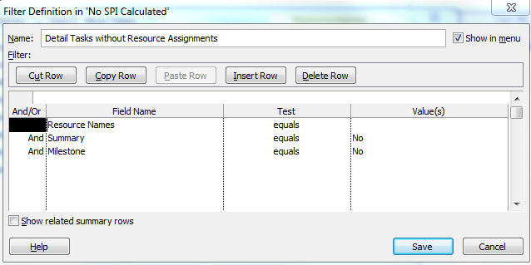

  - Select the new filter from the Filter drop-down list. Any task without a resource assignment will display. Any work attributed to these tasks will not be counted in the Earned Value calculations which will give an inaccurate SPI value.

If any or all of these checks are violated or occur out of the sequence MS Project expects, the tool will not be able to calculate the necessary Earned Value calculations. The result will be an SPI value of 0 in the ‘GEMS Data View’.

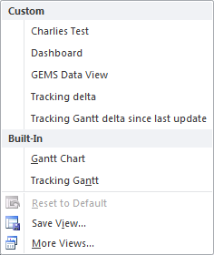
- Has a baseline been set for the project and is the Status Date set to the appropriate date? This must be done before any actual work effort is recorded against a task and after resource assignments have been made.

From the View tab in the Task Views section, click the bottom half of the Gantt Chart button. Select the Tracking Gantt view. When the Tracking Gantt Chart appears click on the Project tab. Click on the ‘Set Baseline’ button and then select the ‘Set Baseline’ option. The following dialog box will appear. If the baseline has not been set the word ‘Baseline’ will appear in the Set Baseline selection box, otherwise the date the baseline was last saved will appear with the word ‘Baseline’.

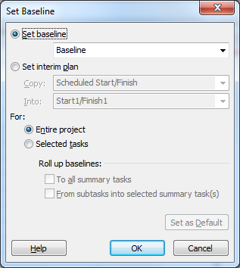

NOTE: Another way to view baseline data is to select the Baseline table from the View tab, Tables button and select More Tables option, then select ‘Baseline’ table and click Apply. If no baseline is set then there will be no data. This view will also tell you if a task has no resource assignment or the resource has no rate by looking at ‘Baseline Cost’. A zero value means no resource is assigned or there is no rate.

The ‘Status Date’ button will display the last Status Date entered into the system.
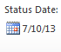
Make sure it matches the current Status Date.

If the baseline has not been set, the information needed for comparison to the actual work and cost is not captured. The Planned Value data for Earned Value calculations will not be available. If actual work has already been entered before the baseline is set, this work will not be counted in the Earned Value calculations.

The next section will describe how to correct a value of 0 for the SPI field.

Correcting a zero-valued SPI in the GEMS Data View
How to correct the schedule will depend on the checklist violations.

- If there are missing resource assignments the project manager must correct this. Run the filter from the checklist item (2.a) and note the tasks that do not have resource assignments. Communicate this to the project manager. If no work effort has been attributed to the task there is no problem to worry about, yet!
- If the Baseline Start, Finish, or Work fields show ‘NA’ the baseline was not set. If the Actual Work field shows ‘0 hrs’ for all tasks there is no problem. Inform the project manager to set the baseline and Status Date before entering actual work effort.
However, if Actual Work exists check the Resource Sheet for the ‘Std. Rate’. If there are no rates entered this will need to be corrected as well, if they do exist only a baseline is needed. Go to Scenario 2 in the Correction Section.
- If the Baseline Start, Finish, or Work fields are populated a baseline exists. If Actual Work shows ‘0 hrs’ and resources have rates there is no problem. If Actual Work exists and Baseline Cost does not exist, the resource rates do not exist and this will need to be corrected and the schedule rebaselined. Go to Scenario 1 in the Correction Section.

Correction Section:
Scenario 1: Baseline is set, Actual Work exists, and a Resource is assigned, but no SPI
- Identify the assigned resource
- Open the Resource Sheet and enter an amount into the ‘Std. Rate’ field for the resource. Also validate that all resources have a value in the ‘Std. Rate’ field.
- Select the ‘Fix GEMS SPI’ table.
- Select the ‘Act. Dur.’ column, right click and select Copy
- Select the ‘Saved Act Dur’ column, right click and select Paste.
- Select ‘Act. Dur.’ column again, right click and select Cut (this clears the data).
- Select the Project tab. Select the ‘Set Baseline’ button, select the ‘Clear Baseline’ option. Select the option to Clear the Baseline plan for entire project, click OK.
- Again select ‘Set Baseline’ button, then select the ‘Set Baseline’ option. Select the Set Baseline for Entire project and click OK. This resets the baseline.
- Select the ‘Fix GEMS SPI’ table again.
- Select the ‘Saved Act Dur’ column, right click and select Copy.
- Select the ‘Act. Dur.’ Column, right click and select Paste. This will re-establish the actual work effort.
- Select the ‘GEMS Data Table’ and the SPI should now be re-established.

Scenario 2: Baseline is not set, Actual Work exists, Baseline Work is zero, and a Resource is assigned, but no SPI
- Identify the assigned resource
- Open the Resource Sheet and enter an amount into the ‘Std. Rate’ field for the resource. Also validate that all resources have a value in the ‘Std. Rate’ field.
- When the baseline is set the SPI and all other baseline fields will be set correctly.
- Select the ‘GEMS Data Table’ and the SPI should now be re-established.

