# Requesting access to Usage Accounting Reports through OrderNow!

**Follow these steps:**

1. If not already completed, have the user self-register using their agency email address in lower case letters at <https://www-01.ibm.com/services/connect/portal>
2. Once logged into OrderNow! Click on **Super User Access Only** from the left navigation menu.
3. Click on Add to cart under the **Request Access to Service Desk, Service Catalog, or Reports**.
4. Click on **Service Information Needed** (in red font).
5. Fill out the top part of the Boarding Book Template.
6. Scroll down the page to see the last item – **Access to Usage Accounting Reports**.
7. Click on Save then Checkout.

**Steps with screen captures are below.**

Once logged into OrderNow! Click on **Super User Access Only** from the left navigation menu.

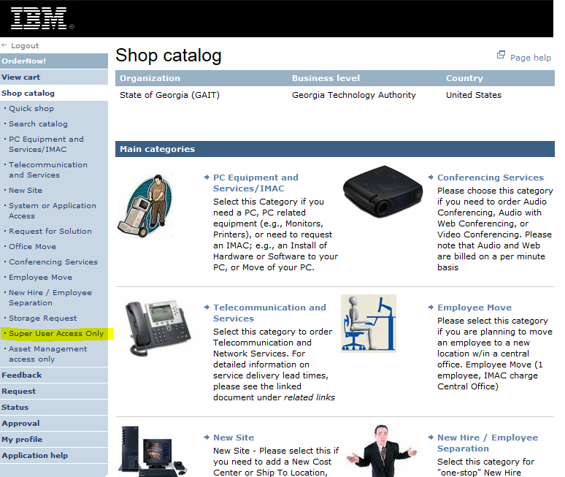

Click on Add to cart under the **Request Access to Service Desk, Service Catalog, or Reports**.

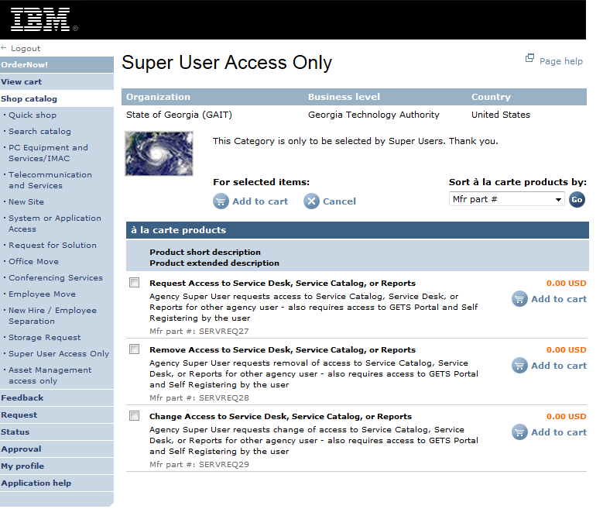

Click on Service Information Needed (in red font).

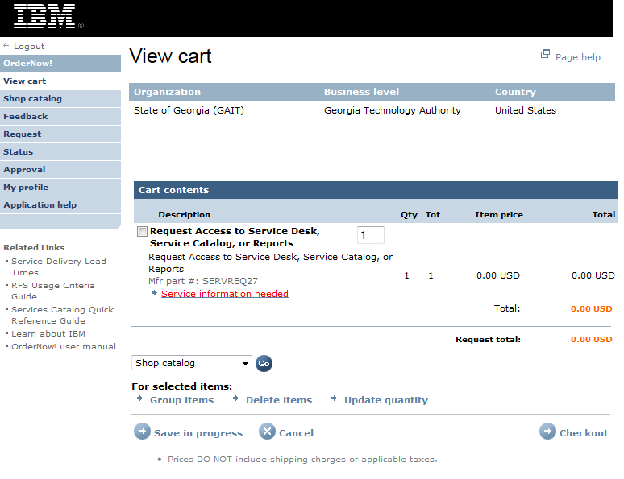

Fill out the top part of the Boarding Book Template. The letter case of the email address should match the email address used to register with the GETS Portal.

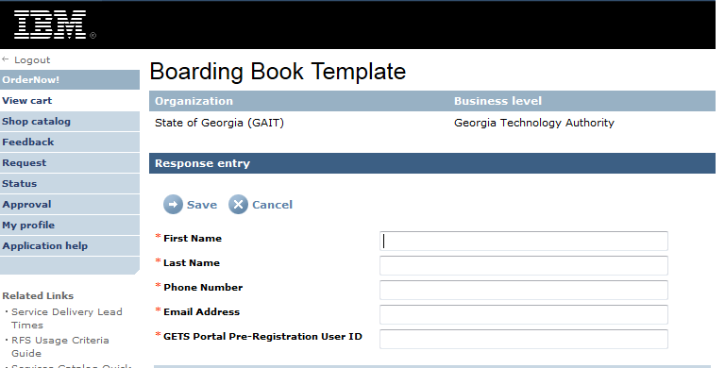

Scroll down the page to see the last item – Access to Usage Accounting Reports.

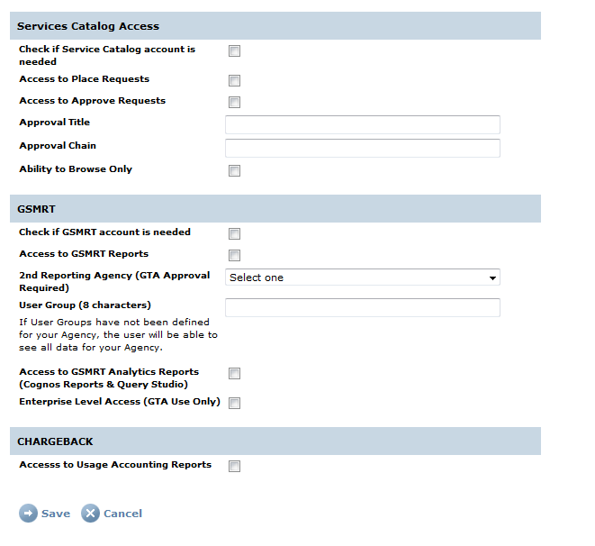

Click on Save then Checkout.